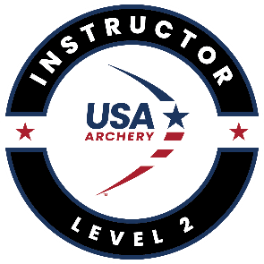**USA Archery Level 2 Instructor Practical Course**

The USA Archery Level 2 Instructor Certification provides graduates with the necessary tools to serve as an instructor for long-term archery programs such as Junior Olympic Archery Development (JOAD), Scouts, 4H, YMCA, etc.

This course combines the USA Archery Level 1 Instructor Certification information with an introduction to the National Training System (NTS) Steps of Shooting for recurve and compound, equipment and accessory setup, athlete development, intermediate coaching techniques and events.

To successfully complete the requirements for this certification, students must;

1. Obtain membership to USA Archery ($70 per year or $165 for 3 years)
2. Complete the USA Archery Safesport on-line program (no cost)
3. Pass USA Archery Background Screening (Please note: you will not be able to register for the Level 2 course until the screening has been cleared by NCSI. Screenings typically take about 7-10 business days. ($25 – good for two years)
4. Successfully pass the USA Archery Level 2 Instructor Certification online course, including the online exam. ($25) A Level 1 Instructor certification is NOT a prerequisite for this course.
5. Complete the "in-person" USA Archery Level 2 Instructor practical course which is being offered here (cost $25 – waived for DSC members)
   1. When: Sunday, September 24th, 2023, 9:00 AM – 5:00 PM
   2. Where: Detroit Sportsmen’s Congress Clubhouse/Indoor Archery Range
   3. Registration must be done on-line.

Go to <https://usarchery.sport80.com/public/wizard/a/246/home> to initiate the on-line process.

Contact Coach Trainer Dave Oles for additional information/questions.

Call or text: 248-221-9308

Email: [dave.oles@comcast.net](mailto:dave.oles@comcast.net)